Updated Candidate Ownership:
All candidates need to be tracked in JobDiva even if the interviews are being scheduled out of system or directly with the end-client manager. If not tracked the ownership will be split with the recruiter who tracks, it first in JobDiva. ALL jobs need to be entered in JobDiva to ensure that proper candidate ownership rules can be administered.
Q: What do attributes mean to MMI & recruiting/sales? What are the rules?
A: Speaking to a candidate on the phone at length and qualifying them for a current and/or future position within MMI’s client business
- Other indicators of what completes true attributes: active/complete email & phone #; accurate/updated resume uploaded (whether MMI formatted or PDF)
- If the candidate has never existed in JobDiva: (obtained through referral, LinkedIn, or some other source), a submission doesn’t have to be logged to have 45-day ownership and connect rules would apply moving forward, as well as submits, interviews, any communication logged, resets the ownership date, etc.
Q: How to get ownership of a new candidate?

Complete attributes collected template:
- When collecting attributes, go to the candidate’s profile and click on the red pin icon.
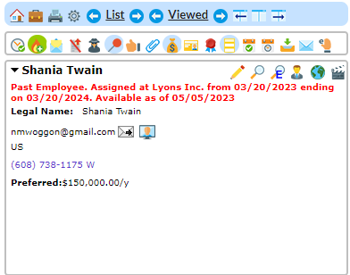

- When in the attributes section, use the IT template and enter the collected attributes and click “save”.
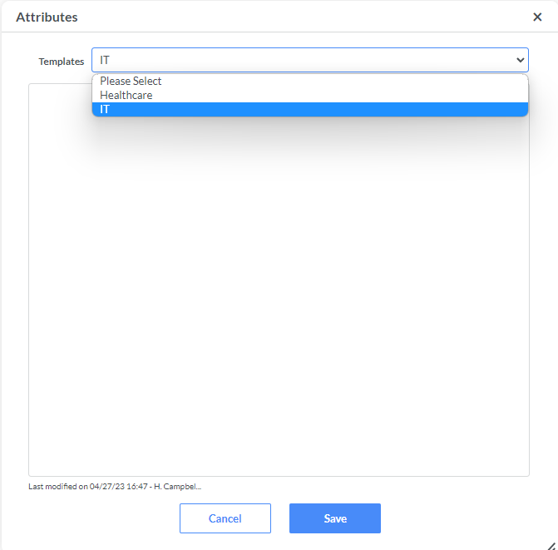

- When reporting your Attributes Collected in the notes section, go into the notes section, and add a new note.

- When adding a new note, choose the note action “Attributes Collected/Modified” and copy the attributes collected from the attributes section and paste it in the body of the notes section.
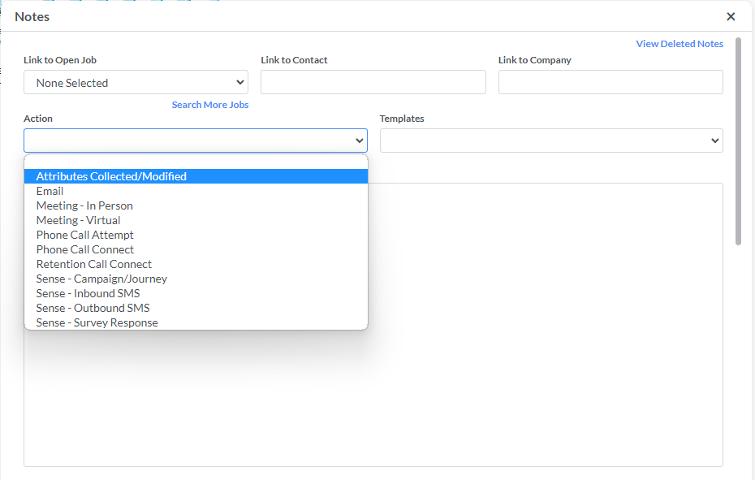.
Updated Attributes Template:
- Current situation / Why are they on the market?
  - (Why are they looking overall, “I WANT SOMETHING NEW” doesn’t count, there has to be a real reason)
  - What's the most important detail for a new position/ideal position? (industry, size, culture)
- Background/ Top Skills/strengths – (minimum 3 to 5 + skills)
- Are they looking for Direct Hire, Contract for Hire, or Contract roles? Current employment status? (w2 c2c or IC {NOT 10-99})
- Visa Status (USC, GC, H1B, OPT TN1 L1 etc.)
- Compensation Expectations (hourly, salary, Benefits, bonuses, equity, Etc.)
- Location (remote, hybrid/onsite FT)/Open to travel (%)/Open to relocate?
- What’s their interview activity (active or passive?/ offers ?)/ availability to interview.
  - Availability to start + what would stop them (vacations, bonus payout, child on way etc.)
General Notes: collect additional info for Pitch (ex. Selling Points, Previous experience, communication skills, red flags, gaps in resume etc.)
Insufficient Attributes: (1 or more of the following are missing)
1. Key Skills in bullet form
2. Current/Asking Rates
3. Visa Details and H1b details in particulars
4. Why leaving/Wants
Updated Resume:
- To add an updated resume, click the resume icon on the candidate’s page.
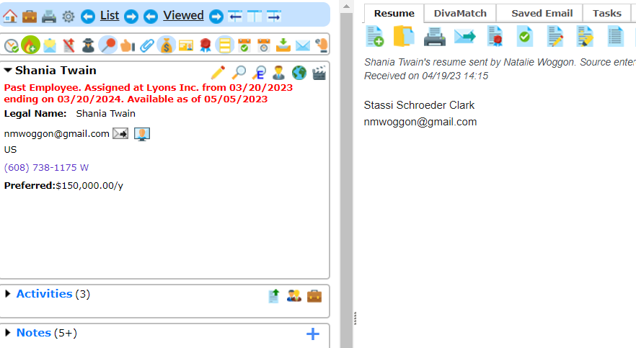
Update Contact Information
- When updating the candidate’s contact information, click on the pencil icon on the candidate's page and enter the updated information.
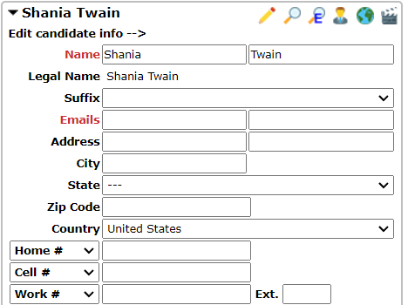
Taking Over Ownership:
- To take over ownership completely, click on the qualifications section.
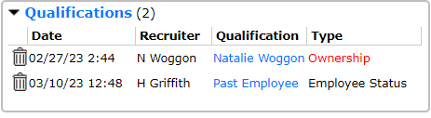
- Click on ownership and find your name to fully take over ownership.
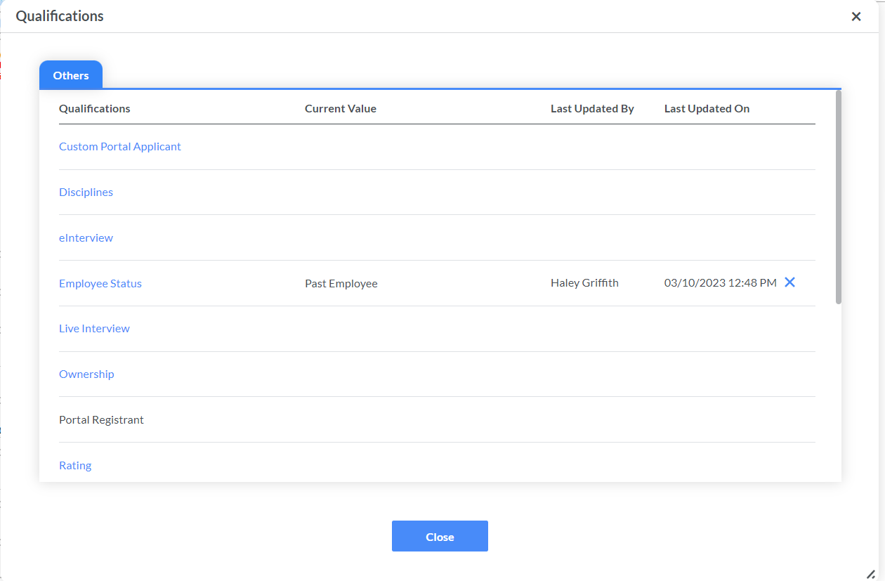
Q: What about if the candidate has existed in JobDiva prior?

A: Whether submitted or not – but there’s been prior recruiter/sales ownership, new ownership requires that a submit + new attributes collected + updated contact information (if provided) must take place to take ownership
(Outside of the 45-day contact ~which is to be logged OR if the past owner is no longer employed at MMI)

- Must be added into the connect action drop down (date and initials)

Insufficient renewal attributes collected:
- No updated comp
- No updated resume
- No Visa status update
- No Updated location
- No Updated contact information
- No updated skills

**Ownership timelines change of MMI employee – whether FT or CNS**
- *45 days for CNS
- *45 days for FT

What is needed for new ownership taken of an existing candidate in JobDiva that falls outside the 45day ownership rules and/or the referral candidate rules?

- Based off last point of contact regardless/note/connect action*
- If ZERO connects/candidate activity on prior owned candidate in JobDiva, new resume and full attributes collected is a must.
- Day 46 (CNS) or day 46 (FT) - Compensation, interview activity/job status currently, visa status, reason for leaving again, location, any new/updated skills (what has been learned, new interests). – copy and update original attributes noted and upload new (erase old) & update candidate connect action drop down tab with new date/initials.
- To take full ownership – the candidate must submit to a role.

Q: how long does ownership last for past placed/current candidates?
Past Placements:
- Full time:
  - Ownership for 12 months from placement and with quarterly (90 day or within) check ins/ connects maintains lifetime ownership.
  - No other recruiter should reach out for 12 months actively - no hunting and no proactive reach out.

- CNS
  - Ownership during contract and after 45 days from end date must reach out every 45 days for retention connect while on assignment + connects maintains lifetime ownership.
  - No other recruiter should be actively reached out while on assignment- no hunting and no proactive reach out.
- ALL RECRUITERS MUST CROSS REFERENCE systems & tools in JobDiva, i.e., LinkedIn, Dice, Monster, etc.- before reaching out to a candidate.

Q: What constitutes a retention connect?

A: Candidate must reply for it to count as a connect-- NOT just attempt. Email, Call, LinkedIn Text.

What Constitutes a Referral:

- A candidate or client directly gives recruiter Contact info, then recruiter making a connection + collect resume.
- Net New: need the information from above- regular ownership rules apply even WITHOUT submission.
- Existing in JobDiva: Need to be based off last connect from OG owner and ownership rules. To get the referral, recruiter 2 must see that recruiter 1 did not meet the criteria.

PERCENTAGE RULES
Candidate ownership entitles you to:
- 100% commission on candidates you place, full placement credit.
- 70% commission should you place a candidate owned by your peers, full placement credit on CNS.
- 30% commission on candidates owned by you; that are placed by your peer on CNS.
- 70% commission should you place a candidate owned by your peers, full placement credit on FT.
- 30% commission on candidates owned by you that are placed by your peer on FT.
- 50% commission split in the event someone places your “True Referral.”
- ½ placement credit to each recruiter in the books
  - 50% commission split in the event someone else places your current/past employee
- ½ placement credit to each recruiter in the books

DISCLAIMERS AND EXCEPTIONS TO THE RULES:
- You CANNOT take ownership of a candidate from your current peers UNLESS you generate an EXTERNAL SUBMISSION for a current job opening at MMI. (No cherry picking on day 46 of no contact and putting your name on a candidate).
- In the event that a recruiter leaves MMI, you also can take ownership of his/her candidate with complete attributes, updated resume and submission or NOT would constitute to take ownership.
- In the event that an interview request comes in AFTER a transfer of ownership has occurred, the ORIGINAL owner will be permitted to proceed with the candidate on that specific opportunity ONLY (but will give up 30% of placement to the new owner – this only counts if 90days past the date of submission)

CURRENT CONSULTANTS ON BILLING: (ending soon or unhappy) and PAST CONSULTANTS ON BILLING:

*** If recruiter #2 comes to knowledge of candidate through LinkedIN, and/or a referral is made, job portals, any conversation had, etc. however; no cross-reference is done in JobDiva to see the current activity but, there's an interest in new position – that recruiter (#2) whom sent the message MUST check JobDiva – and if on assignment, then original recruiter (candidate owner) is notified right away and NO new ownership/submittal activity can occur. If so, instant conversation with Matt F. and/or Paul C.

- If you are caught omitting resumes or contact information in JobDiva, you will:
  - Earn 1% commissions on all future billings (if person is still working)
  - Earn 1% commissions should the person be replaced at a new client
  - A second offense will result in zero commissions paid and a conversation with Gene Holtzman.

- Updated resumes AND accurate contact information, for these candidates, MUST be fully visible in JobDiva at the time of ALL submittals to new opportunities!

